Welcome to
immanuel united reformed church

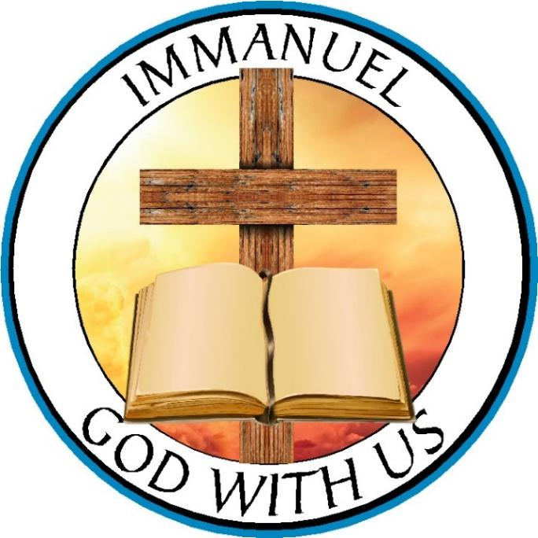
Sunday, August 13, 2023
Worship Services: 10:00 am & 5:00 pm
Hymn Sing 4:50 pm

Rev. Roberto Rossi, Pastor
Rev. Ken Anema, Associate Pastor
Rev. Nathan Brummel, Associate Pastor

Morning Worship Service

Prelude
God Calls His People

Call to Worship
Silent Prayer-concluded by minister
*Votum
Pastor: Our soul waits for the LORD; He is our help and our shield.
Congregation: For our heart is glad in Him, because we trust in His holy name.
*Salutation
*Hymn of Praise: 219:1-5.....................................................................................................O Worship the King

God Pardons His People

Reading of God’s Law
Assurance of Pardon
Song of Confession & Assurance: 51B:1-5, 7................................................................God, Be Merciful to Me
Congregational Prayer
Offering of Tithes & Gifts: .........................................................General Fund and Reformed Youth Services

God Speaks to His People

*Song of Preparation: 78:1-4.........................................................................O My People, Hear My Teaching
Reading of the Word: .....................................................................................................Exodus 10:1-20 (p. 61)

Sermon: LOCUSTS INVADE EGYPT

God’s People Respond

Prayer of Application
Song of Application: 244.....................................................................................A Mighty Fortress Is Our God

God Blesses His People

*Benediction
*Doxology: 473:1, 3...........................................................................................................By the Sea of Crystal
*Silent Prayer–concluded by the Postlude
*Postlude

*Please stand if able.

Evening worship service

Prelude
God Calls His People

Call to Worship
Silent Prayer - concluded by minister
*Votum
Pastor: Our soul waits for the Lord; He is our help and our shield.
Congregation: For our heart is glad in Him, because we trust in His holy name.
*Salutation
God’s People Offer Praise

*Confession of Faith.................................................................................................................Apostles’ Creed
*Hymn of Praise: 220............................................................................................................Give Praise to God
Psalm Reading........................................................................................................................Psalm 146 (p.622)
Singing of the Psalm: 146 ...................................................................Praise the Lord! My Soul, O Praise Him!
Congregational Prayer
Offering of Tithes & Gifts: .........................................................General Fund and Reformed Youth Services

God Speaks to His People

*Hymn of Preparation: 119H..................................................................................You, LORD, Are the Portion
Reading of the Word: .....................................................................................................................Acts 2:36-47
Catechism Reading, Lord’s Day 25 ........................................................................Forms and Prayers, (p. 226)

Sermon: RECEIVE THE WORD & SACRAMENTS

God’s People Respond
Prayer of Application
*Song of Application: 190............................................................................Thus Saith the Mercy of the Lord

God Blesses His People

*Benediction
*Doxology: 570...................................................................................................................................Doxology
*Silent Prayer–concluded by the Postlude
*Postlude

*Please stand if able.

THIS WEEK AT immanueL:
Coffee Fellowship after the morning worship service.
Nursery AM: Abby Dyke and Livy Cox PM: Elizabeth DeJong and Sophie Bakker
On-call Nursery Attendant: Amanda Staley
Sound System: Peter Brummel
Greeters AM: Kirsten DeBoer (South), Woldt Family (North), Noah Anema (Elevator)
Greeters PM: John Dyke, Jr. Family (South), Carson & Leanna Bakker (North), John Hamstra (Elevator)
Song Service: Cade Walstra; Songs: 133B, 281, 476
Monday: Deacons meet at 7:00 pm.
Tuesday: Council meets at 7:00 pm.

next week SUnday: AUGUST 20
Coffee Fellowship after the morning worship service.
Nursery AM: Sue DeBoer and Emmelene Dyke PM: Mary Vander Molen and Naomi Dyke
On-call Attendant: Janell Rottier
Sound System: Thomas Bousema
Greeters AM: Dale & Marie Eenigenburg (South), Rob Buiter Family (North), Jacob Dyke (Elevator)
Greeters PM: Justin Colanese Family (South), Dan & Beth Kingma (North), Amos Terpstra (Elevator)
Song Service: Peter Brummel

Upcoming dates:
August 22: Building & Grounds Committee meets at 7:00 pm
August 27: Baptism Service. Divine Hope Reformed Bible Seminary presentation after morning worship.
September 10: Sunday School and catechism begin.
October 1: Fellowship Meal after morning worship.

Congregational Care

- Jay Staley
- Barb Meppelink
- Jim Kuiper
- Amber Green
- Expectant mothers: Cami Stegenga, Leanna Bakker and Sydnie Walstra
- Teen Mother Choices (TMC)
- Our students and teachers as they begin a new school year

Apostles’ Creed

I believe in God the Father Almighty, Maker of heaven and earth. I believe in Jesus Christ, his only begotten Son, our Lord; who was conceived by the Holy Spirit, born of the virgin Mary;
suffered under Pontius Pilate; was crucified, dead, and buried; he descended into hell; the third day he rose again from the dead; he ascended into heaven, and sits at the right hand of God the Father Almighty; from there he shall come to judge the living and the dead. I believe in the Holy Spirit; the holy catholic church; the communion of saints; the forgiveness of sins; the resurrection of the body; and the life everlasting. Amen

United in Prayer-Missionary Prayer Requests

Rev. Nathan Brummel is a professor in the Divine Hope Reformed Bible Seminary.

- Pray that the LORD will call inmate graduates to teach theology in prison and
when they get out.
- Pray for inmate facilitator A. B. (names not allowed) who is taking chemotherapy
medicines for cancer.
- Pray for more volunteer teachers to meet the demand of reaching 143 prisons
with study centers.

Deacon Report

Offering Schedule:
Today: General Fund and Reformed Youth Services
August 20: General Fund and Mid-America Reformed Seminary
August 27: General Fund and DeMotte Christian Schools, Inc.

All cash donations not placed in an envelope and designated will go to the second offering cause.
All checks with no designation on the memo line will go to the second offering cause.
With gratitude to God, the deacons report the following offering amounts:

General Fund
Benevolence
DeMotte Food Pantry
Divine Hope Reformed Bible Seminary
Consistory Announcements

Gerrit Eenigenburg, son of Calvin and Jessica, will be baptized on August 27.

Beginning next Sunday, August 20, our evening song service will begin at 5:00 pm, and the worship service will immediately follow. The consistory notes that guests relying on a 5:00 pm service time often arrive part way through the song service. This small adjustment in time should help both members and guests to be present for the entire song service.

General Announcements

Pastors Anema and Brummel will give an update on the ministry of Divine Hope Reformed Bible Seminary after the morning worship service on August 27.

Sunday School and Catechism classes will begin September 10.

Our next Fellowship Meal will be October 1.

GEMS: We'd love to have one more leader for the 2023-2024 GEMS year! Please consider joining Carrie Rossi, Amanda Staley and Amber Green. If you can't commit to being a leader for every meeting, could you commit to filling in occasionally as a sub? We'd love to have the extra help when one of our current leaders can't make it to a meeting. If this ministry opportunity interests you, please see Carrie Rossi for more information. We're excited to see what God has in store for this year's GEMS program!

Cadet Counselors are needed for our Cadet season which begins next month. Please contact Jerry Hager as soon as possible if you are interested.

Rockville Bible Study–Would you like to travel to Rockville Correctional Facility on a Friday afternoon with experienced volunteers to observe and participate in the Ladies’ Bible Study at the prison? We are studying the book of James, and you are welcome to join us! Please see John Hamstra to sign up. Also, the Annual Training for all who would like to volunteer at Rockville Correctional Facility has been scheduled for Saturday, August 26, at 9:00 am here at Immanuel. Please see John Hamstra for more information.

“I was in prison and you came to me.” Matthew 25:36b. Divine Hope Reformed Bible Seminary hosts two conferences per year at the Rockville Women’s Facility in Rockville, Indiana. Our next conference will be held September 29 - October 1 with the theme: Walk Thru the Old Testament, a Presentation of the Bible as a Single Story of God's Plan of Salvation from Creation to Christ. If you are 18 years or older, you are invited to attend the Rockville Fall Conference for one or all of the sessions. For more information contact John Hamstra (219) 296-9389 or johnmhamstra@gmail.com.

Word & Deed–You are cordially invited to attend the Illiana Word & Deed Stewardship Group Meeting on Monday, August 21 at 7:00 pm. A Stewardship Group is a group of Christians in a local area coming together to make a significant impact on the lives of disadvantaged people in the developing world by supporting specific Word & Deed projects. See John Hamstra to learn more or to make plans to carpool to the meeting, which will take place at Redeemer URC in St. John, Indiana.

This Coming Saturday, August 12, is the Sporting Clay Fundraiser for Reformed Mission Services. Please sign up today at rms.org/michigan, or register at the door this Saturday. Any questions contact Jim at jim@rms.org.

Our Council:
Elders: Deacons:
President: Jon Hoek (24) Parish 2 President: Jim Zeilenga (25) Parish 2
Vice President: Russ Vander Molen (24) Parish 4 Vice President: Nathan De Jong (25) Parish 3
Clerk: John DeBoer (25) Secretary: Justin Colanese (23) Parish 4
Steve Ryken (23) Parish 3 Treasurer: Joshua Hubers (24)
Mark Van Der Molen (25) Parish 1 Asst. Treasurer: Ray Vander Molen (24) Parish 1

Parishes:

1: Anema – Drenth 2: Dyke – Hubers 3: Ipema – Ryken 4: Staley – Zeilenga

Committees and Contact Person:

Administrative Assistant: Donna Hamstra
Adult Sunday School: Pastor Ken Anema
Bookkeeper: Elaine Dyke
Building & Grounds: Rob Buiter
Bulletin: please contact Administrative Assistant
Cadets: Jerry Hager
Custodians: Dave and Dawn DeGraff
Education: Russ Vander Molen
Evangelism & Outreach: Pastor Roberto Rossi
Fellowship: Wendy Buiter
Funerals: Beth Kingma and Sue DeBoer
GEMS Club: Carrie Rossi
Helping Hands: Naomi Hamstra

Librarian: Maggie Bakker
Men’s Bible Study: Rudy Tolkamp
Nursery: Jessica Colanese
Sound & Video System: Rudy Tolkamp
Special Events Coordinator: Mary Vander Molen
Special Music: Mark Van Der Molen
Story Hour: Stacey Tolkamp
Sunday School: Carolyn Hager
Teen Mother Choices: Stacey Tolkamp
Web Manager: Dana Perkins
Women’s Bible Study: Donna Hamstra
Youth Group: Nathan & Carrie Bakker and
Pastor Roberto Rossi

Church Contact Information:

Office Hours: Administrative Assistant: Tuesday-Friday, 9:00 am-2:00 pm.
Administrative Assistant & Bulletin Announcement Email: immanuelurcsecretary@gmail.com
Address: 9991 W. 1200 N., DeMotte, IN 46310
Office Phone: (219) 987-6247
Pastor Rossi’s Email: immanuelurcpastor@gmail.com
Facebook: Immanuel United Reformed Church, DeMotte, IN
Website: www.immanuelurcdemotte.org

